Teton Canyon Field Trip
Meeting Notes
July 17, 2013

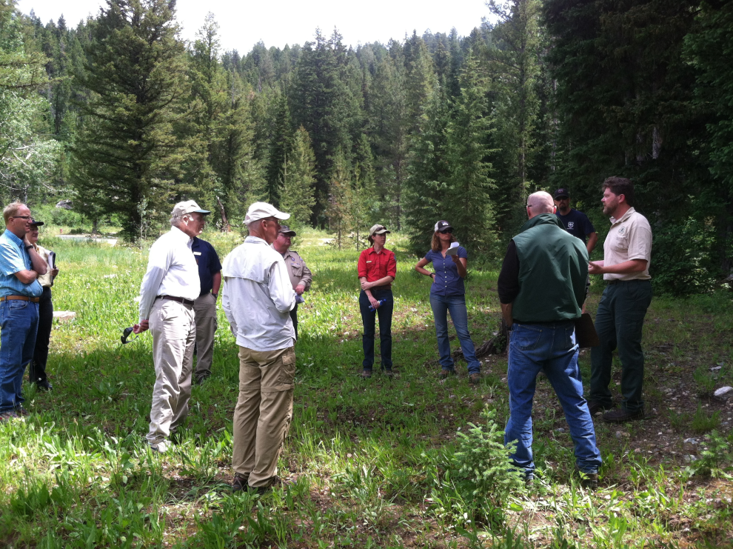

0900 Meet at Teton Canyon Winter Parking Area

Introductions and review agenda/route

Safety briefing regarding driving, slips/trips, allergies, communications, etc..

Stop A – Winter Parking Area

Teton Canyon Big Picture, Fire Management, Wildlife – winter range, Trails
See notes from the evening meeting to speak to these topics mentioned above.

Discussion about the possibility of laying asphalt up Teton Canyon Road to the BSC. This has already been approved but there is no budget for this. Comment from the public – they would support this due to the amount of dust in the summer.

Speed of vehicles driving the canyon road is a concern. Is it possible to place a couple of the flashing speed signs along the road? This is an option.

Questions
Does MgCl impact invertebrates in the watershed?
In the past, only portions of the Teton Canyon Road have had MgCl applied and in small amounts. The amount applied does not have effects on the invertebrates in the watershed.

How does MgCl effect the vegetation?
Stunts the growth of the vegetation.

Will we be discussing later the cost difference between mechanical vs. prescribed fire treatments?
Yes.

How does fire effect weed response?
There will be an increase in weeds initially and then native vegetation will take over.

Stop B – Ward Campsite

Discussion about the changes made to the Ward Campsite – rock barriers to decrease impacts to the creek, bear boxes to encourage appropriate food storage.

Walked to a new dispersed campsite…dispersed camping is spreading/expanding. There are impacts to the creek due to sediment and contamination runoff. Small trees are being cut down to make room for vehicles, RV’s and tents. Additional soil impaction is occurring from vehicles and is also affecting tree roots and leading to tree stress and death.

The spruce stands has great age diversity, this stand will be compared to another site later in the field trip. This age diversity ensures that there will be spruce in the future.

Due to the amount of dispersed camping and the number of campfire rings there is concern for a human fire start to occur and for a wildfire to move up-canyon. This has the potential to impact the safe egress of the public depending on the size of the wildfire.

Questions
Are there waste issues with this much dispersed camping?
We are sure there are but some campers do take it with them.

Do we see more use or impacts to the Canyon during the Targhee Music Festivals?
Some, but not as much as previously, Targhee has created a campground which has reduced a lot of the pressure.

What is the practicality of putting enough stones/etc to keep sediment out of the AIZ (Aquatic Influence Zone)?
We have to have a plan in place to receive funding.

Can you designate dispersed camps as tent only vs. RV?
There are food storage issues and more folks are using vehicles and RV’s for storage, mitigates the need for bear boxes.

When you have an issue unfolding (dispersed camping, user created trails) can you deal with it before it becomes a problem?
Within the Forest Plan (direction for management) that is our direction – dispersed camping is designated in this area. This plan was created with public input – until that changes this is our management direction.

Stop C – Reunion Flats Campground

Bighorn sheep – The Apostles are historic bighorn sheep winter range. Bighorn sheep no longer winter here, partly because of conifer expansion. Bighorn sheep rely on their eyesight to detect predators and therefore, require open habitat with good sight distances. As conifer trees expand into areas, bighorn sheep are pushed out. We know that a GPS-collared bighorn sheep passed through Teton Canyon during summers 2008 and 2009. We would love to have sheep utilize this area again during the winter. Vegetation treatments could improve bighorn sheep habitat. Key habitat for mule deer, elk, and moose is mountain shrub communities, but unfortunately, most of the shrubs are too tall for these ungulates to reach and too old to produce vigorous growth, which is the food ungulates rely on during the winter.

Potential treatments in this area could be to mechanical slash some of the trees and follow up with prescribed fire. Forest Plan direction prohibits us from removing timber from areas with slopes greater than 40%. These areas in the Apostles is greater than 40%. Looking for a mosaic of treatment, would like to have an uneven aged stand.

Treatments typically span over a few years – but this all depends on the treatment type and in this case what we actually develop as our treatment type.

Peregrine Falcon – There are some located in the Apostles. Want to limit the skier impact to this area.

Mt. Mahogany – great forage for animals but not much available and within reach, would like to stimulate some regeneration for winter forage.

Campground vs. dispersed camping use.

Questions
What is the existing fire policy up Teton Canyon?
Suppress all fires in the canyon.

Stop D – Teton Canyon Horse Corrals
Aspen Ecology and Potential Treatment Options.

Look at the difference from one side of parking lot to the other. Aspen were cleared for the parking lot, look how they are regenerating. This is an example of how disturbance will stimulate regeneration.

Aspen stands are great fire breaks and great for wildlife. If we can stimulate some aspen regeneration within these areas where aspen is being encroached upon by conifer we can meet two objectives of improving vegetation diversity and mitigating some of the hazardous fuel loadings.

Some examples of successful aspen treatments across the District – We will slash conifer that is encroaching within aspen stands. The cut material will be left on the ground to red-needle and we will then follow up with a prescribed fire 6 months to 1 year later. We do this to broaden our prescription window for prescribed fire b/c we can burn under cooler conditions and mimic natural fire. Results – (Hill Creek Rx) – 2000 – 3000 aspen suckers per acre. Results will vary based on productivity of the site.

Comment – There is good literature on aspen management. That could be used for designing and prioritizing treatments.

Questions
What are the packets on the trees?
Verbenone – this is a pheromone repellant packet for the Mountain Pine Beetle.

Fungal diseases affecting aspen – will fire change that?
Everything likes aspen, this is natural for there to be a little fungus on the aspen.

Stop E – Teton Canyon Campground

Wilderness, Moose and Big Picture – mosaic.

Great view of aspen stands being encroached by conifer - south facing slope, north of the Teton Canyon Road.

Treatments need to be a mosaic – there is great value in stand and age class diversity.

Large spruce are located within this campground. This stand needs some small openings for a little sun and shade to stimulate some new spruce seedlings. Potential treatment – open up some “house sized” pockets to a balance of shade and sunlight to stimulate some seedlings. Potentially use mechanized equipment/timber sale to remove these logs.

Trails – A trail north of the Teton Canyon Road has been approved since 2004. Has not been created b/c of the lack of funds.

Questions
Could some of this material be used as firewood?
There is some potential but would not want firewood cutters dragging logs through the campground throughout the summer.

How could the material be removed?
Loggers – timber sale, firewood cutters.

